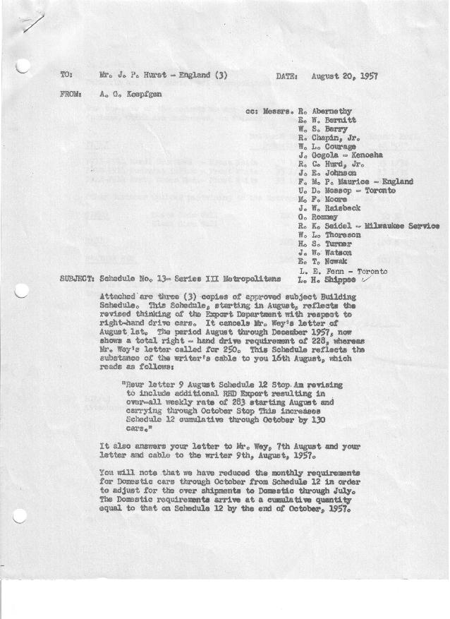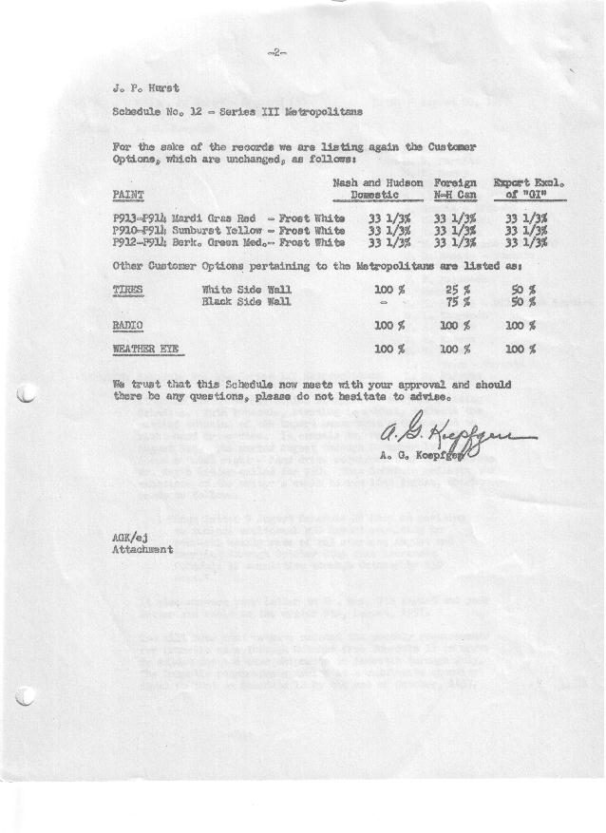

FORM PLAN 68 REV. 2-55-A.M.P Page 1 of 2 APPROVED R. Abernethy (signed) DATE 8/21/57

SCHEDULE NO. ______13 ___ DATE 8-20-57 MONTHLY BUILDING SCHEDULE APPROVED E.W.Bernitt (signed) ___ _ DATE_ 8/21/57 _
REVISION NO. _______ ______ DATE PRODUCT APPROVED Unknown (signed)) DATE _ 8/21/57 ____
SERIES III 1500 c.c. ENGINE
METROPOLITAN SERIES CARS – AUSTIN MOTORS CO., LTD, ENGLAND
DESCRIPTION | BUILT  ◻ACTEST  THRU  7-28-57 | FIRM BUILDING SCHEDULE  (FABRICATED MATERIAL RELEASE) |  |  |  |  |  |  |  |  |  |  |  |  |  |  | TENTATIVE SCHEDULE  (RAW MATERIAL RELEASED) |  |  | GRAND  TOTAL
DESCRIPTION | BUILT  ◻ACTEST  THRU  7-28-57 | MONTH August “57”  DAYS 15 |  |  | MONTH September  DAYS 21 |  |  | MONTH October  DAYS 23 |  |  | MONTH November  DAYS 21 |  |  | MONTH December  DAYS 19 |  |  | MONTH January “58”  DAYS 23 |  |  | GRAND  TOTAL
DESCRIPTION | BUILT  ◻ACTEST  THRU  7-28-57 | DAILY | MONTH | CUM’L  TOTAL | DAILY | MONTH | CUM’L  TOTAL | DAILY | MONTH | CUM’L  TOTAL | DAILY | MONTH | CUM’L  TOTAL | DAILY | MONTH | CUM’L  TOTAL | DAILY | MONTH | CUM’L TOTAL | GRAND  TOTAL
DOMESTIC LHD:
Hard-Top | 14167 |  | 674 | 14841 |  | 898 | 15739 |  | 984 | 16723 |  | 924 | 17647 |  | 681 | 18328 |  | 683 | 19011
Soft-Top | 2255 |  | 58 | 2313 |  | 126 | 2439 |  | 138 | 2577 |  | 126 | 2703 |  | 75 | 2778 |  | 76 | 2854
Total U.S. | 16422 | 48.8 | 732 | 17154 | 48.7 | 1024 | 18178 | 48.8 | 1122 | 19300 | 50.0 | 1050 | 20350 | 39.8 | 756 | 21106 | 33.0 | 759 | 21865
Over/(Under) Schedule 12 | 72 |  | (18) | 54 |  | (26) | 28 |  | (28) | -0- |  | -0- | -0- |  | -0- | -0- |  | -0- | -0-
FOREIGN:
EXPORT LHD Hard-Top | 569 |  | 18 | 587 |  | 32 | 619 |  | 20 | 639 |  | 31 | 670 |  | 20 | 690 |  | 40 | 730
Soft-Top | 280 |  | 15 | 295 |  | 10 | 305 |  | 7 | 312 |  | 9 | 321 |  | 8 | 329 |  | 12 | 341
Total Export LHD | 849 |  | 33 | 882 |  | 42 | 924 |  | 27 | 951 |  | 40 | 991 |  | 28 | 1019 |  | 52 | 1071
RHD Hard Top | 104 |  | 32 | 136 |  | 49 | 185 |  | 56 | 241 |  | 37 | 278 |  | 14 | 292 |  | 60 | 352
Soft Top | 22 |  | 10 | 32 |  | 10 | 42 |  | 11 | 53 |  | 3 | 56 |  | 6 | 62 |  | 6 | 68
Total Export RHD | 126 |  | 42 | 168 |  | 59 | 227 |  | 67 | 294 |  | 40 | 334 |  | 20 | 354 |  | 66 | 420
Grand Total Export | 975 | 5.0 | 75 | 1050 | 4.8 | 101 | 1151 | 4.1 | 94 | 1245 | 3.8 | 80 | 1325 | 2.5 | 48 | 1373 | 5.2 | 118 | 1491
Over/(Under) Schedule 12 | 81 |  | 14 | 95 |  | 17 | 112 |  | 18 | 130 |  | -0- | 130 |  | 10 | 140 |  | 13 | 153
CANADA Hard-Top | 1736 |  | 42 | 1778 |  | 64 | 1842 |  | 86 | 1928 |  | 30 | 1958 |  | 10 | 1968 |  | 110 | 2078
Soft-Top | 148 |  | 0 | 148 |  | 0 | 148 |  | 0 | 148 |  | 0 | 148 |  | 5 | 153 |  | 5 | 158
Total Nash Canada | 1884 | 2.8 | 42 | 1926 | 3.0 | 64 | 1990 | 3.7 | 86 | 2076 | 1.4 | 30 | 2106 | .8 | 15 | 2121 | 5.0 | 115 | 2236
Over/(Under) Schedule 12 | 3 |  | (3) | -0- |  | -0- | -0- |  | -0- | -0- |  | -0- | -0- |  | -0- | -0- |  | -0- | -0-
Total Foreign | 2859 | 7.8 | 117 | 2976 | 7.9 | 165 | 3141 | 7.8 | 180 | 3321 | 5.2 | 110 | 3431 | 3.3 | 63 | 3494 | 10.2 | 233 | 3727
Over/(Under) Schedule 12 | 84 |  | 11 | 95 |  | 17 | 112 |  | 18 | 130 |  | -0- | 130 |  | 10 | 140 |  | 13 | 153
GRAND TOTALS
Hard-Top | 16576 | 51.1 | 766 | 17342 | 49.7 | 1043 | 18385 | 49.8 | 1146 | 19531 | 48.7 | 1022 | 20553 | 38.2 | 725 | 21278 | 38.9 | 893 | 22171
Soft-Top | 2705 | 5.5 | 83 | 2788 | 6.9 | 146 | 2934 | 6.8 | 156 | 3090 | 6.6 | 138 | 3228 | 5.0 | 94 | 3322 | 4.3 | 99 | 3421
Total | 19281 | 56.6 | 849 | 20130 | 56.6 | 1189 | 21319 | 56.6 | 1302 | 22621 | 55.3 | 1160 | 23781 | 43.2 | 819 | 24600 | 43.2 | 992 | 25592
Over/(Under) Schedule 12 | 156 |  | (7) | 149 |  | (9) | 140 |  | (10) | 130 |  | -0- | 130 |  | 10 | 140 |  | 13 | 153

FORM PLAN 68 REV. 2-55-A.M.P Page 2 of 2 APPROVED R. Abernethy (signed) DATE 8/21/57

SCHEDULE NO. ______13 ___ DATE 8-20-57 MONTHLY BUILDING SCHEDULE APPROVED E.W.Bernitt (signed) ___ _ DATE_ 8/21/57 _
REVISION NO. _______ ______ DATE PRODUCT APPROVED Unknown (signed)) DATE _ 8/21/57 ____
SERIES III 1500 c.c. ENGINE
METROPOLITAN SERIES CARS – AUSTIN MOTORS CO., LTD, ENGLAND
DESCRIPTION | BUILT  ◻ACT◻EST  THRU | FIRM BUILDING SCHEDULE  (FABRICATED MATERIAL RELEASE) |  |  |  |  |  |  |  |  |  |  |  |  |  |  | TENTATIVE SCHEDULE  (RAW MATERIAL RELEASED) |  |  | GRAND  TOTAL
DESCRIPTION | BUILT  ◻ACT◻EST  THRU | MONTH February  DAYS 20 |  |  | MONTH March  DAYS 21 |  |  | MONTH April  DAYS 20 |  |  | MONTH May  DAYS 22 |  |  | MONTH June  DAYS 2.6 |  |  |  |  |  | GRAND  TOTAL
DESCRIPTION | BUILT  ◻ACT◻EST  THRU | DAILY | MONTH | CUM’L  TOTAL | DAILY | MONTH | CUM’L  TOTAL | DAILY | MONTH | CUM’L  TOTAL | DAILY | MONTH | CUM’L  TOTAL | DAILY | MONTH | CUM’L  TOTAL | DAILY | MONTH | CUM’L TOTAL | GRAND  TOTAL
DOMESTIC LHD:
Hard-Top |  |  | 561 | 19572 |  | 659 | 20231 |  | 681 | 20912 |  | 784 | 21696 |  | 54 | 21750
Soft-Top |  |  | 99 | 2953 |  | 157 | 3110 |  | 97 | 3207 |  | 121 | 3328 |  | 41 | 3369
Total U.S. |  | 33.0 | 660 | 22525 | 38.8 | 816 | 23341 | 38.9 | 778 | 24119 | 41.1 | 905 | 25024 | 36.5 | 95 | 25119
Over/(Under) Schedule 12 |  |  | -0- | -0- |  | -0- | -0- |  | -0- | -0- |  | -0- | -0- |  | (222) | (222)
FOREIGN:
EXPORT LHD Hard-Top |  |  | 30 | 760 |  | 30 | 790 |  | 30 | 820 |  | 30 | 850 |  | 12 | 862
Soft-Top |  |  | 9 | 350 |  | 10 | 360 |  | 10 | 370 |  | 10 | 380 |  | 4 | 384
Total Export LHD |  |  | 39 | 1110 |  | 40 | 1150 |  | 40 | 1190 |  | 40 | 1230 |  | 16 | 1246
RHD Hard Top |  |  | 30 | 382 |  | 30 | 412 |  | 28 | 440 |  | 10 | 450 |  | 3 | 453
Soft Top |  |  | 4 | 72 |  | 10 | 82 |  | 7 | 89 |  | 3 | 92 |  | 1 | 93
Total Export RHD |  |  | 34 | 454 |  | 40 | 494 |  | 35 | 529 |  | 13 | 542 |  | 4 | 546
Grand Total Export |  | 3.6(3.7) | 73 | 1564 | 3.8 | 80 | 1644 | 3.7 | 75 | 1719 | 2.4 | 53 | 1772 | 7.7 | 20 | 1792
Over/(Under) Schedule 12 |  |  | 11 | 164 |  | 30 | 194 |  | 25 | 219 |  | 3 | 222 |  | -0- | 222
CANADA Hard-Top |  |  | 100 | 2178 |  | 200 | 2378 |  | 200 | 2578 |  | 200 | 2778 |  | 19 | 2797
Soft-Top |  |  | 30 | 188 |  | 50 | 238 |  | 35 | 273 |  | 15 | 288 |  | 4 | 292
Total Nash Canada |  | 6.5 | 130 | 2366 | 11.9(12) | 250 | 2616 | 11.8 | 235 | 2851 | 9.8 | 215 | 3066 | 8.8 | 23 | 3089
Over/(Under) Schedule 12 |  |  | -0- | -0- |  | -0- | -0- |  | -0- | -0- |  | -0- | -0- |  | -0- | -0-
Total Foreign |  | 10.2 | 203 | 3930 | 15.8 | 330 | 4260 | 15.5 | 310 | 4570 | 12.2 | 268 | 4838 | 16.5 | 43 | 4881
Over/(Under) Schedule 12 |  |  | 11 | 164 |  | 30 | 194 |  | 25 | 219 |  | 3 | 222 |  | -0- | 222
GRAND TOTALS
Hard-Top |  | 36.1 | 721 | 22892 | 43.8 | 919 | 23811 | 46.9 | 939 | 24750 | 46.6 | 1024 | 25774 | 33.8 | 88 | 25862
Soft-Top |  | 7.1 | 142 | 3563 | 10.8 | 227 | 3790 | 7.5 | 149 | 3939 | 6.7 | 149 | 4088 | 19.2 | 50 | 4138
Total |  | 43.2 | 863 | 26455 | 54.6 | 1146 | 27601 | 54.4 | 1088 | 28689 | 53.3 | 1173 | 29862 | 53.0 | 138 | 30000
Over/(Under) Schedule 12 |  |  | 11 | 164 |  | 30 | 194 |  | 25 | 219 |  | 3 | 222 |  | (222) | -0-

